1.a

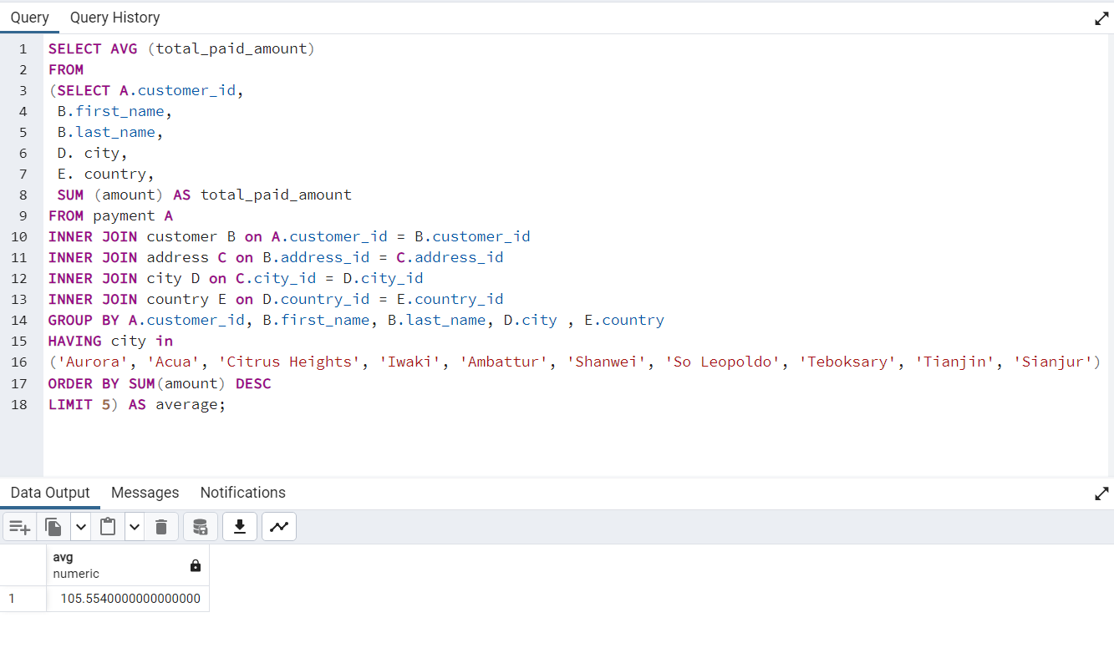

2.a

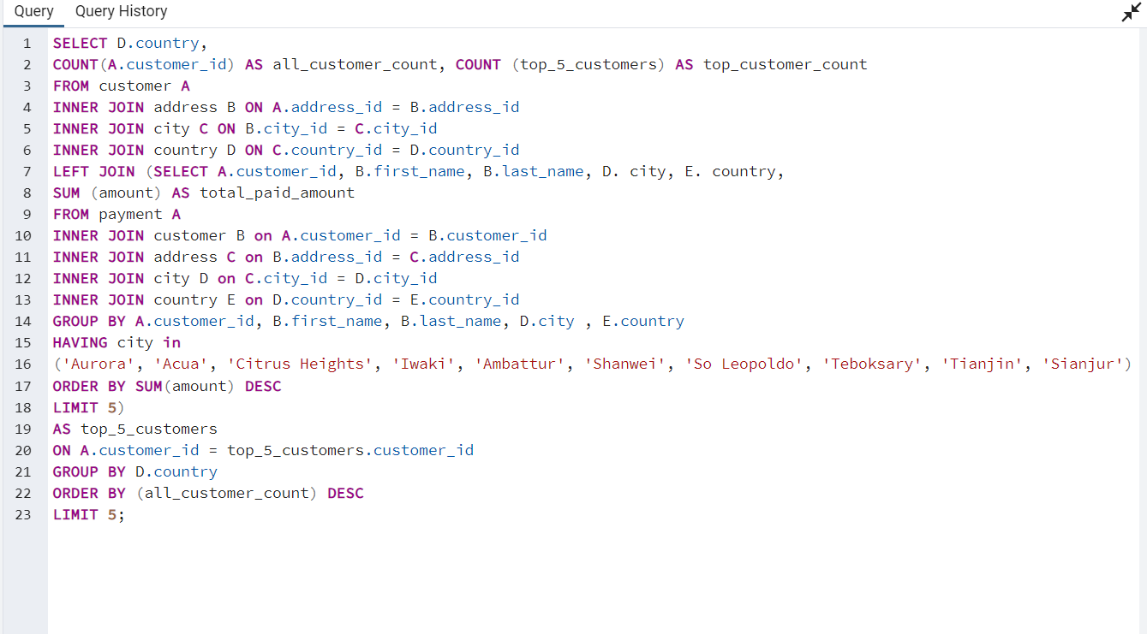

3.a I think this query could have been done without subqueries because subqueries slow the process down and we could have used a JOIN. If you are deciding between using or not using a subquery one of the top things you can ask yourself is the data changing frequently. If yes then use subqueries to bring in the latest data. If needing to consider this, then running an “EXPLAIN” could help to determine if using a subquery is cost effective.